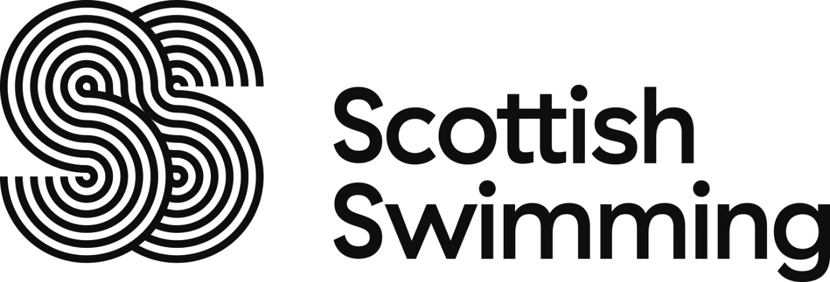

Membership Check
As a member, some of your personal information will automatically appear on the online membership checker (https://www.scottishswimming.com/membership/membership-check.aspx) as detailed in Scottish Swimming’s privacy policy. This allows officials to confirm that you are a member of Scottish Swimming when competing, officiating or applying for funding for courses. The information that is available to the general public is: name, membership number, clubs that you are a member of, gender, membership category and country of international representation.
Rankings system
All swimmer’s information will automatically appear on the British Swimming Rankings Website (http://www.swimming.org/britishswimming). This is where details of your achievements in events will be included; these will be available to the general public.
To Opt Out
If you do not want your details to be visible on the rankings or the membership checker you can hide them placing a ‘tick’ in the box in the ‘OptIns’ tab on the Scottish Swimming online membership system (azolve) or by sending an email to info@scottishswimming.com with your request to hide your details.
Caution – ​ If you ‘hide’ your details they will not be visible on the Rankings Database or the online membership checker - this may affect your ability to enter events. Event organisers may in these cases require proof of age and/or of eligibility to enter and you should contact the particular organiser to check.

